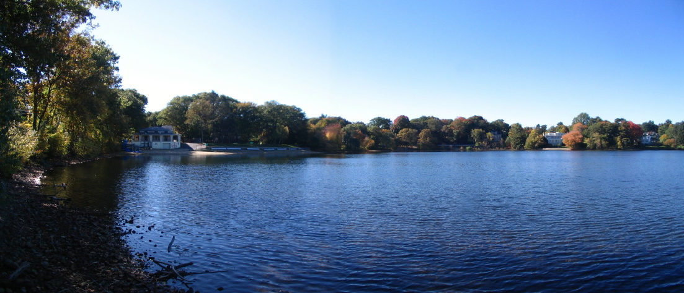

Come Join Us for an Afternoon of Fun and Information!!

***“PADDLES AND PUMPKINS”***

**SUNDAY October 4, 2015**

**Rain or Shine!**

**CRYSTAL LAKE BATHHOUSE**

20 Rogers Street, Newton Highlands, MA

**1:00pm-5:00pm**

**Support Crystal Lake Conservancy’s efforts to keep Crystal Lake healthy**

**$10 per canoe/kayak/paddleboard**

**Cider, Strung Donuts Game & Pumpkin Decorating**

**Sponsors: The Village Bank, Whole Foods, Dunkin Donuts, Shaws, Wegmans**

The Crystal Lake Conservancy and the Newton Parks and Recreation Department invite you to join us for a Sunday afternoon of activities on Crystal Lake. Participants sign up for half hour slots between 1:00-5:00pm to enjoy the pleasures of canoeing/kayaking/paddleboarding. A lifeguard will be on duty and all participants will be required to wear life jackets and sign a waiver. Children under 16 must be accompanied by an adult. In addition all can enjoy catching strung up donuts, drinking fresh cider and decorating your own free pumpkin!!

**Learn about ongoing testing and watershed activities to protect Crystal Lake!!**

Visit our website at [www.CrystalLakeConservancy.org](http://www.CrystalLakeConservancy.org) or call Janice Bourque at 617-967-0797.

